ACCIDENT / INCIDENT INVESTIGATION REPORT
Date of Accident / Incident: 21.12.18 Time of Accident Incident: 05.30am
The person who had the accident / incident

Name: Firas Hassan Ali Title: Mrs

Address: N/A

Nationality: Date of birth: 10.10.82

Tel: 07930222132
Age: 36
Occupation: Cleaning Operative

Person filling in this form

Name: Gareth Williams Title: Mr

Address: 1 AXIS COURT,
RIVERSIDE BUSINESS PARK,
MALLARD WAY,
SWANSEA VALE,
SWANSEA,
SA7 0AJ

Tel: 01792 793021
Fax: 01792 793 137
Mobile: Occupation: Contract Manager

Signature: ....................................................................................................................

About the accident / incident

1. Site name & Address: Redivodd Building Cardiff Uni
2. Dept / location of the accident / incident: 0.17 A/B
3. Work being undertaken: Replenishing refuse sack
4. Nature of the incident: Contact with sharp – Needle disposed of in general waste
E.g. slip/trip/fall/contact, with hazardous substance, building, equipment, etc
5. Nature of the injury: Needle protruded through the skin of the middle finger on left hand
E.g. cut/fracture/bruising/swelling/torn ligaments, etc

6. Part(s) of the body injured; (Circle on Diagram)

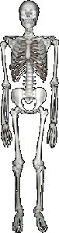
- Middle finger on left hand

7. Was first aid given? [X] Y [] N
8. Was Hospital treatment given? [X] Y [] N
9. What Treatment/Medication was given: Gareth Williams provided first aid by cleaning the wound with a sterile cloth. Firdas then visited her G.P.
10. Name of person / hospital giving first aid / treatment / medication:
Gareth Williams.

Injured Person Description

(Please state in your own words with relevant times, what was happening at time of the incident, what you observed, and in as much detail as possible)

I was emptying white tissues from inside the general waste bin by hand placing it inside the general waste bin. The bin was on the floor along side a sharps bin to the left of it.

I was in the lab 0.17A/B on my own doing my normal round when I placed my hand into the bin I felt a sharp prick into my finger, when I looked I noticed that there was a needle in the general waste bin and this had gone into my left middle finger.

I remember my hand and noticed it was bleeding, I placed a tissue over the wound and contacted my Manger Gareth who arrive and gave me first aid. He asked if I wanted to visit A&E but I refused and decided to visit my own G.P.

I was fine after the incident and carried on to the end of my shift.

(Firdus Ali 21.12.18)

Signature: ...................................................................... Date: ..............................
Continue Over Leaf

Work status

Was the injured person: (please tick relevant box):
- Went back to work [X]
- Went / Sent home [ ]
- Went / Sent to hospital [ ]

Witness to Accident / Incident Details

1 Name: N/A Address: N/A

2 Name: N/A Address: N/A

MANAGEMENT REPORT.

Immediate Causation | Contact with sharps
Basic Causation | Operative was removing tissues from refuse sack and came into contact with a used needle

Supervisor (if applicable): Date:

Signature:

Contract Manager: Date:

Signature:

First Date of Absence | NA | Date Return to Work

Second Date of Absence |  | Date Return to Work

Action / Steps to Prevent Reoccurrence: -

Action  Required | By Whom | Target  Date/Cost
Contact with sharps Toolbox Talk to be completed with cleaning staff by Contract Manger  Discuss with Cardiff University Estates/Health & Safety how incorrect disposal of waste is addressed by Laboratory staff | Gareth Williams  Petra Kopf | Completed on the 04.01.19  To be discussed in meeting 22.1.19

Name of person reporting incident / accident: Frias Ali

Name of person investigating: Gareth Williams / Lewis Elsey / Denna Exon

Detailed description of incident / accident:
I Gareth Williams (SSG Contracts Manager) was informed about an incident at Cardiff Uni involving Fridas Hassan (SSG Cleaning Operative) via a phone conversation from Hodan Ahmed (Building Supervisor) at 5.30am on the 21/12/18.

Hodan told me that Fridas had come into to contact with a needle in one of the refuse sacks. I made my way straight to the Redwood building to investigate and check on Fridas.

When I arrived Fridas finger was bleeding, so I administered first aid by using a sterile wipe on her figure which stopped the bleeding. I asked Fridas what happened and she told me she was removing tissues from the refuse sack and felt a pin prick her left hand finger. When she checked there was a used needle sitting in the refuse sack and her finger started to bleed immediately.

After I administered first aid and her finger stopped bleeding, Fridas decided to continue her shift and went to see her local G.P (Dr Saunders) at Butetown Medical Centre Cardiff after work.

No tests are were taken and there are non-outstanding. Fridas didn’t require any time off as a result of this incident and has continued with full duties ever since.

I reported this incident to Petra Kopf (Facilities Manager) who passed it on to Mark Williams Health / Safety. Petra has enquired about re-training Firdas which has been completed.

I also informed our Health and Safety Manager Denna Exon Smith wwho initiated the Investigation. (Gareth Williams 10/01/19)

Attach any photographs or provide sketch
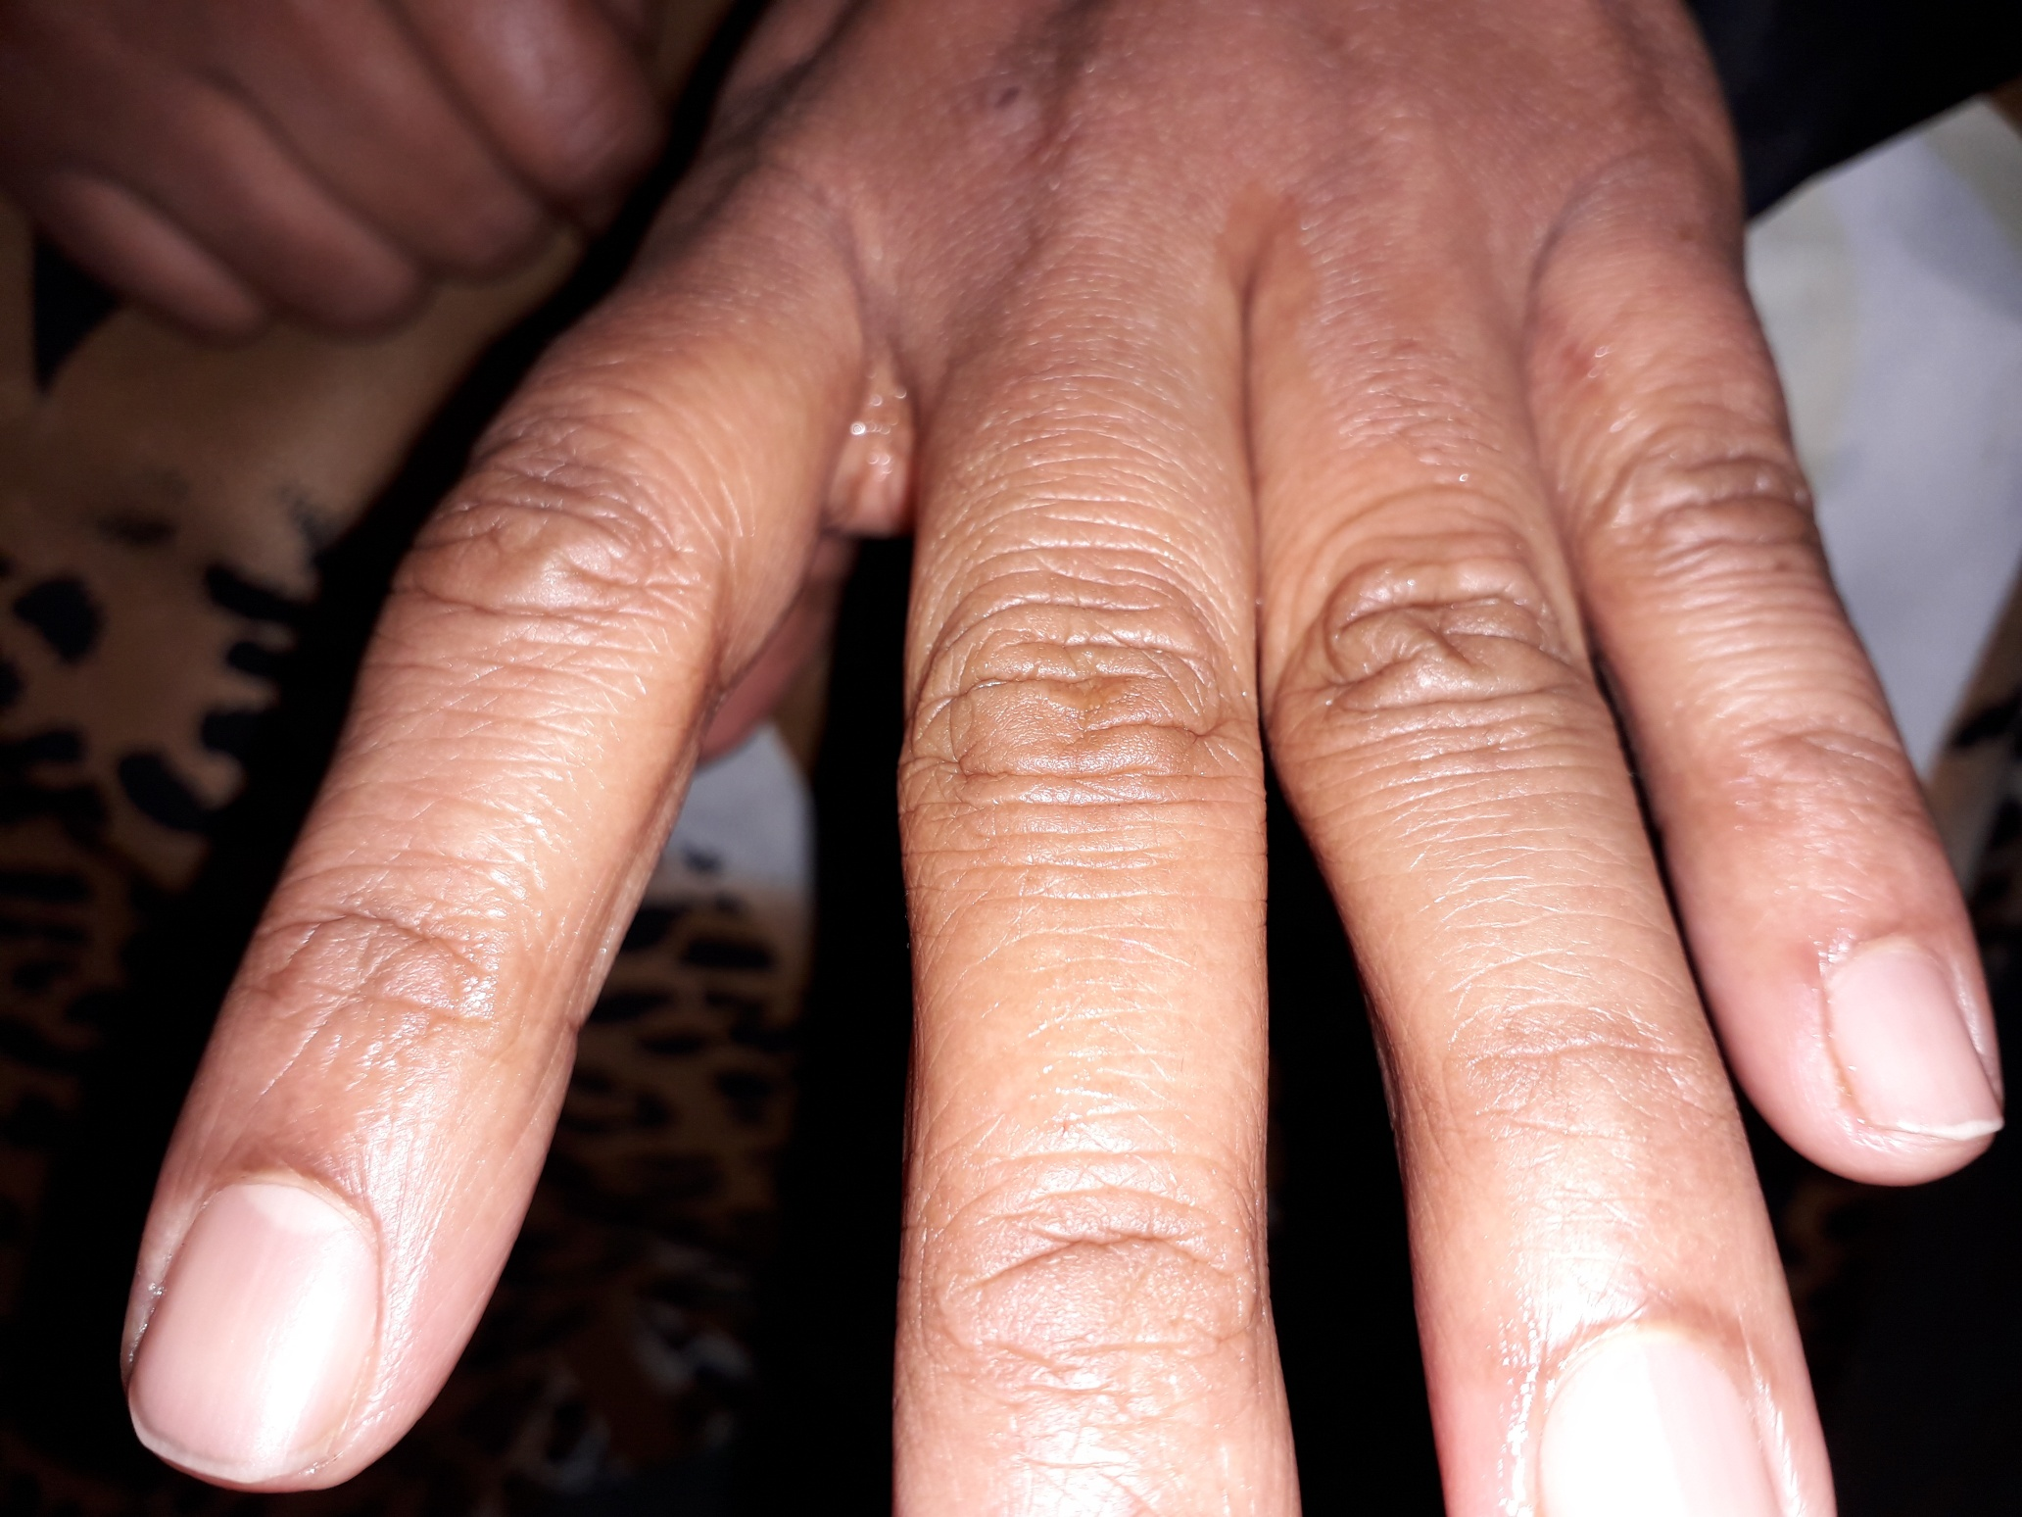
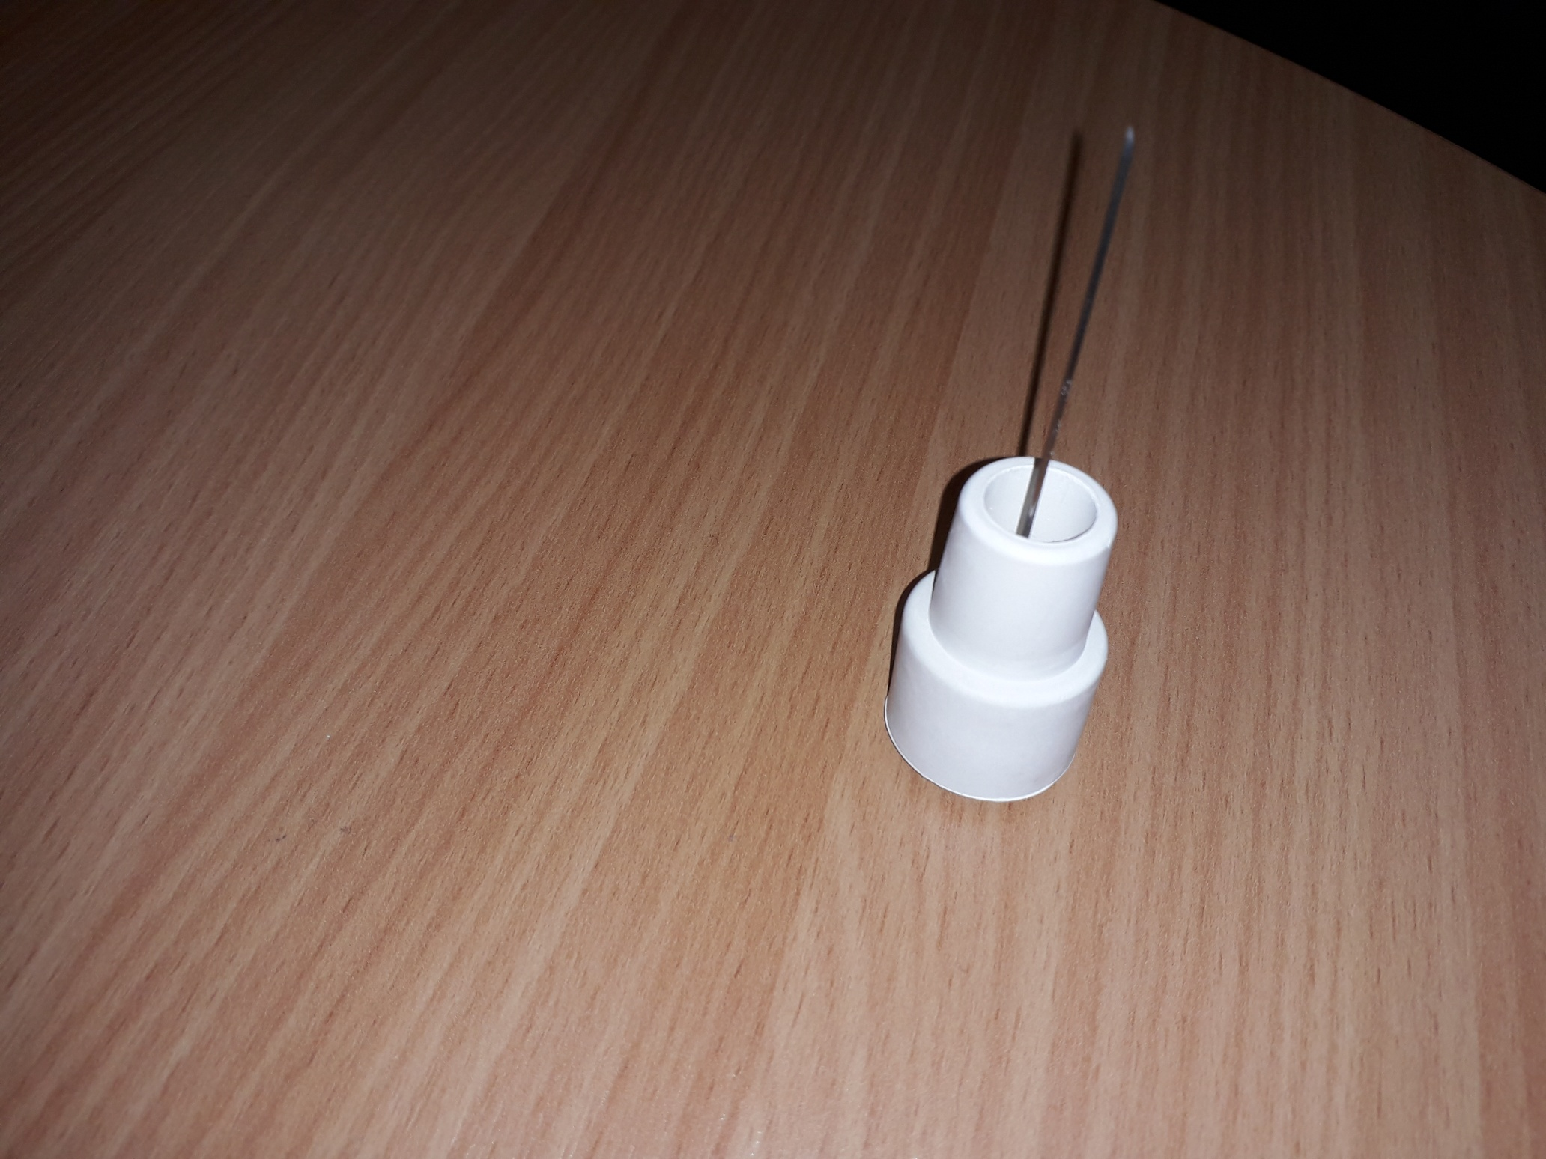

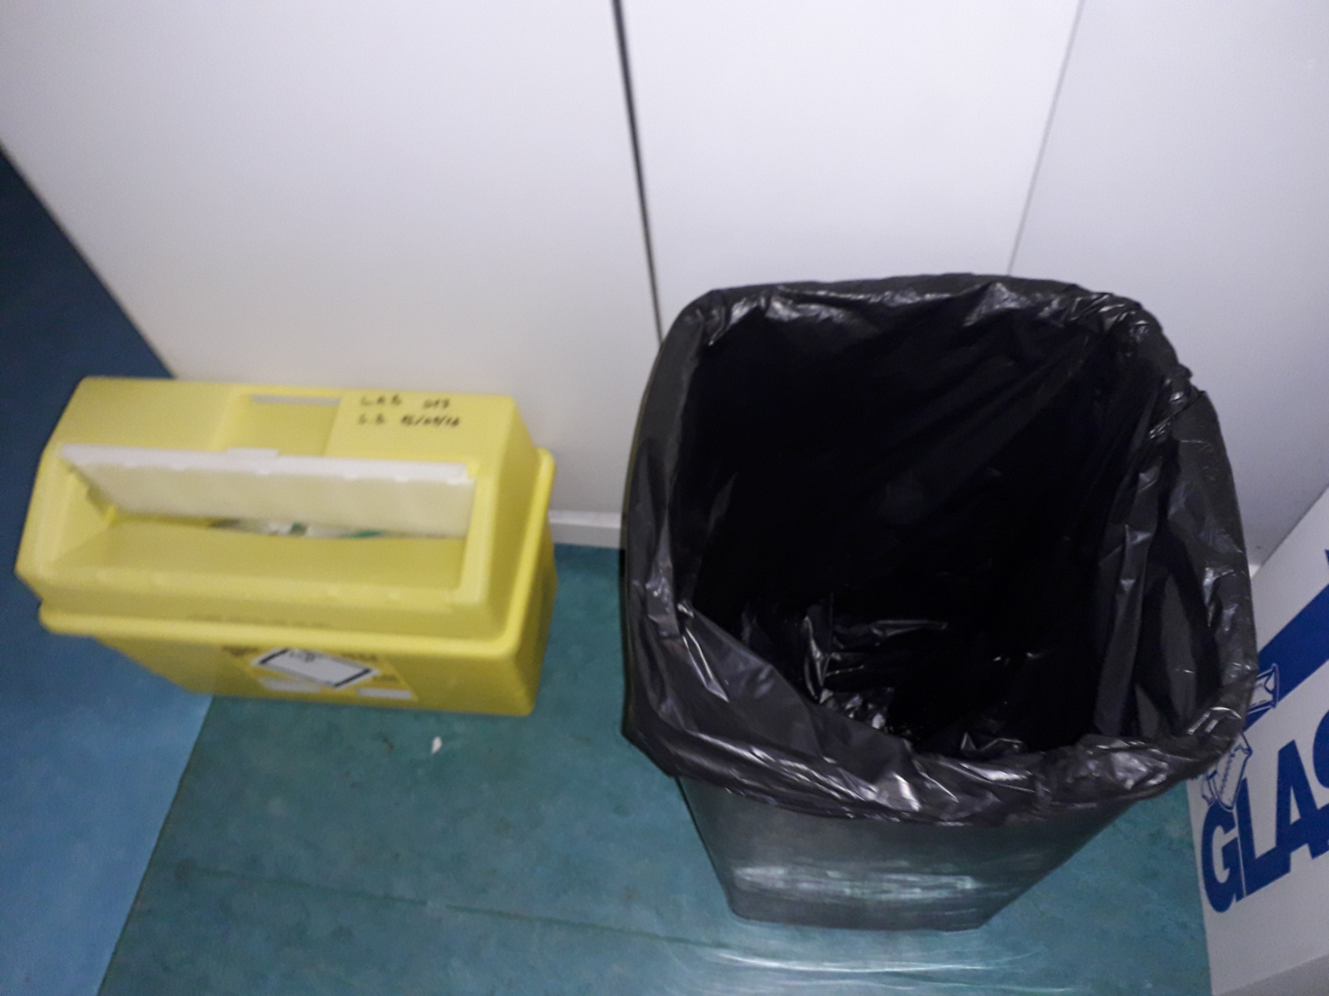
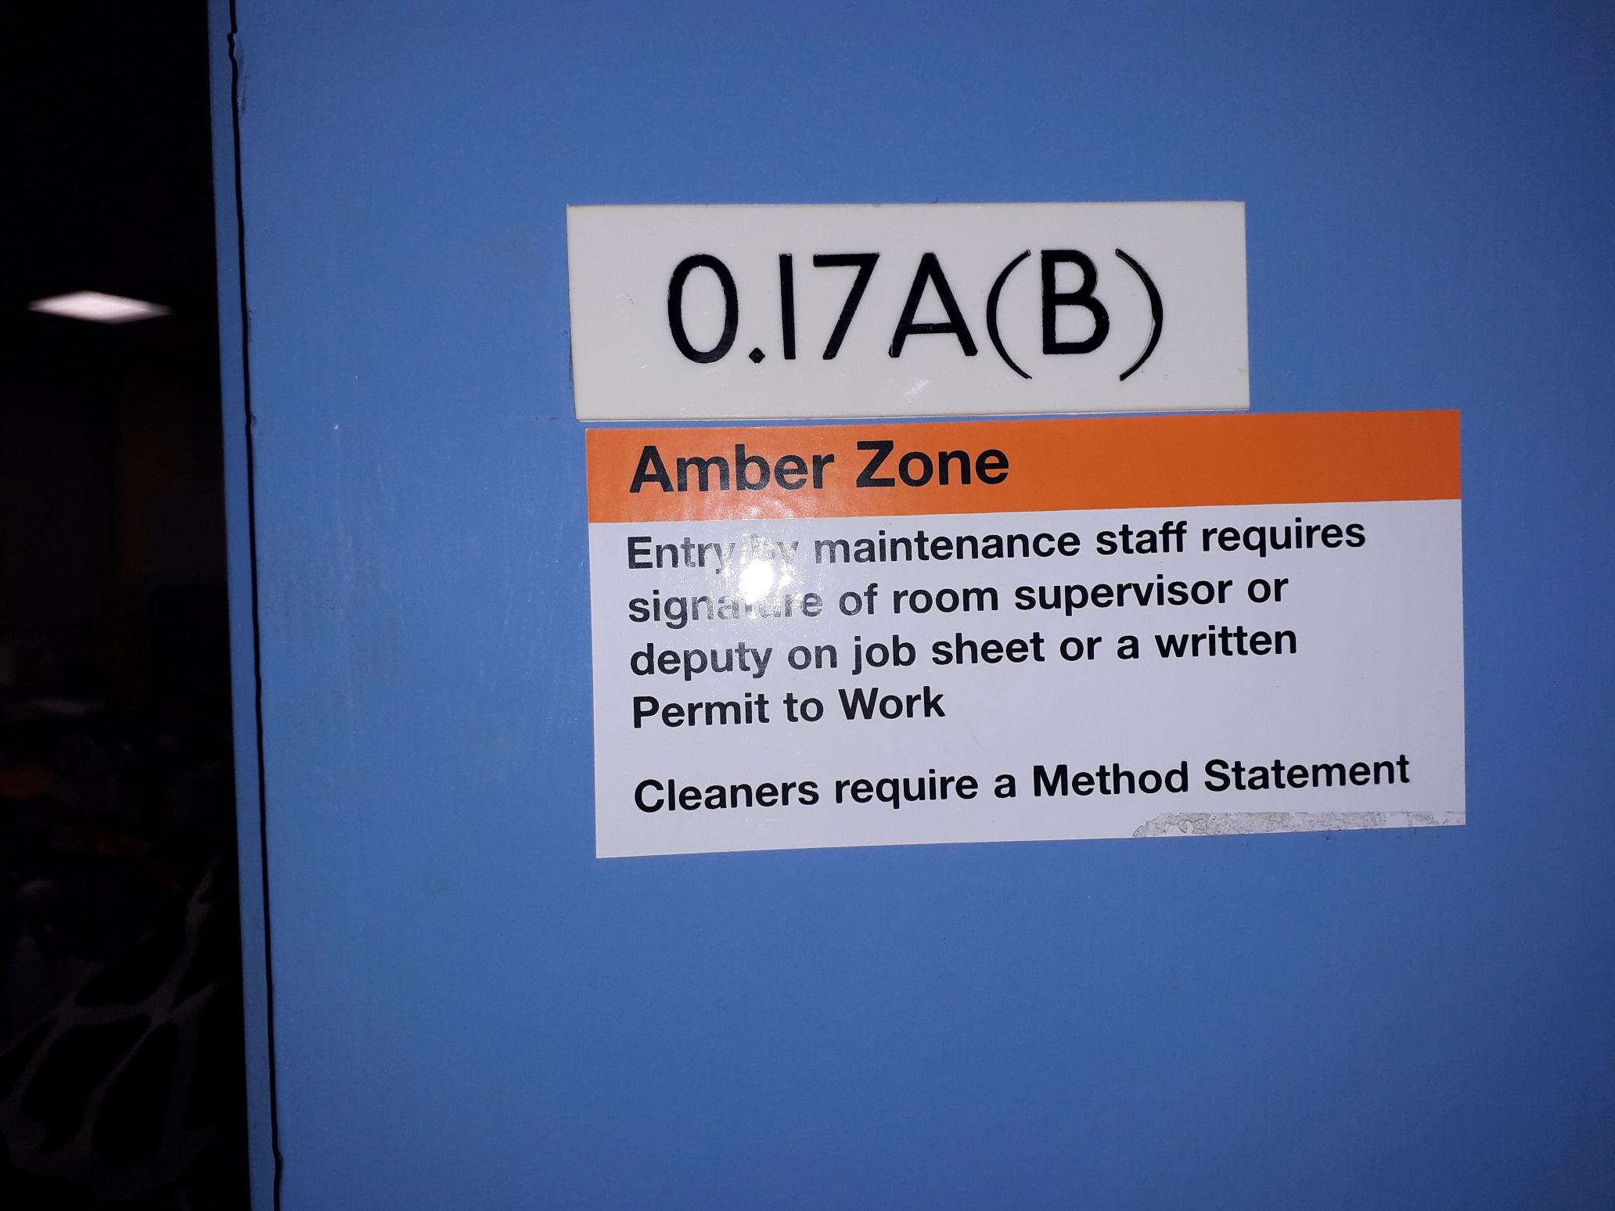

Signed: ______________________________ Date: _____________________
Witness Details / Statement
Name of person:
Address:
(Please state in your own words with relevant times, what was happening at time of the incident, what you observed, and in as much detail as possible)

NO WITNESS

Continue Over Leaf

Witness Details / Statement
Name of person:
Address:
(Please state in your own words with relevant times, what was happening at time of the incident, what you observed, and in as much detail as possible)

NO WITNESS

Continue Over Leaf

SAFETY PROCEDURES AND PERMITS
List any procedures or permits in operation at the time:
Solo Service Group Site Safety Handbook:
Training held on file
Designated sharps Box/Bins in Laboratories

Attach copies to this report
EMPLOYEES
Name of others involved in the investigation; N/A
Solo Employees: Firdas Ali / Gareth Thomas / Dave Hutin / Denna Exon / Lewis Elsey
Site: N/A

Attach copies of witness or other relevant statement
N/A
Where appropriate, provide evidence of training e.g. training records.
Copy of Solo Service Group Site Safety File declaration, anything signed on site

EQUIPMENT
If any vehicle or machine was involved, state type, asset, registration and other identification no.
N/A
Attach copies of previous 6 months maintenance and inspection reports. N/A or remedial work carried out as a consequence of this incident:

PROTECTIVE CLOTHING
Was protective clothing/equipment required? [X] Y [ ] N

If yes state type: Gloves + Tabard

If protective clothing equipment was required, was it in use [X] Y [ ] N
Was the correct type in use? [X] Y [ ] N [ ] N/A
If yes, describe its condition:
Good Condition

Was protective clothing being used properly? [X] Y [ ] N [ ] N/A

FOR SAFETY DEPARTMENT USE ONLY

Health and Safety Report Received Date:

MEDICAL DETAILS

Was the injured person detained in hospital? [ ] Y [ X ] N [ ] N/A

If so, for how long:

Was this a Lost Time Injury? [ ] Y [ X] N [ ] N/A

If so, for how long:

Is there any long-term disability? [ ] Y [ X ] N [ ] N/A
If so, please describe:

First date of absence: NA

Date of return to work: NA

INVESTIGATION

Was an F2508 form necessary and completed? [ ] Y [X ] N [ ] N/A
Inc Ref No:
The Incident Contact Centre, local HSE or Local Authority Office informed? Date: [ ] Y [ ] N [ ] N/A

If Yes, please attach a copy of F2508:

Have the HSE investigated? [ ] Y [ ] N [ ] N/A

If Yes, please attach any correspondence:

Clients Accident Book Entry Completed [ ] Y [ ] N [ ] N/A

If Yes, please attach a copy:

Clients Accident Investigation Carried Out [ ] Y [ ] N [ ] N/A

If Yes, please attach a copy:

HEALTH & SAFETY MANAGER’S / OFFICER’S COMMENTS

Health & Safety Manager’s / Officer’s Comments:

Name: ............................................................Signed: .....................................................

Date: ..............................................................

